**LAB MANUAL**



**ROLLNO:AV.SC.U4CSE24124**

**NAME: G . Balaji Ajay**

**SECTION: CSE-B**

**WEEK-1:**

**Aim:** How to install jdk and first program on

printing student details*.*

**Step-1:** Download JDK-21 from oracle website

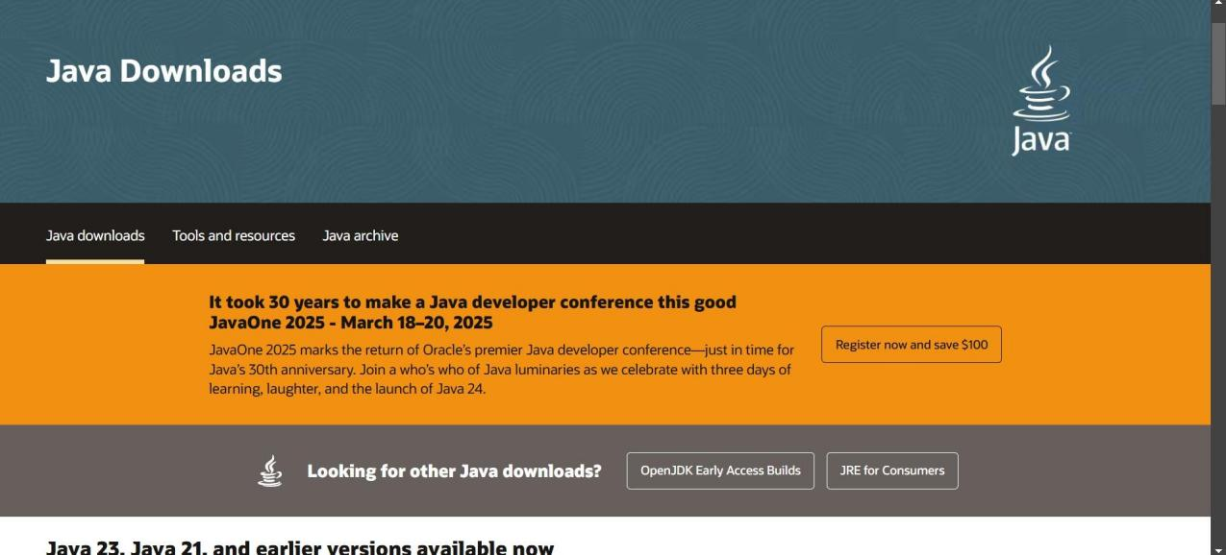

**Step-2:**Install the JDK-21 with accepting terms and

conditions according to the respective windows.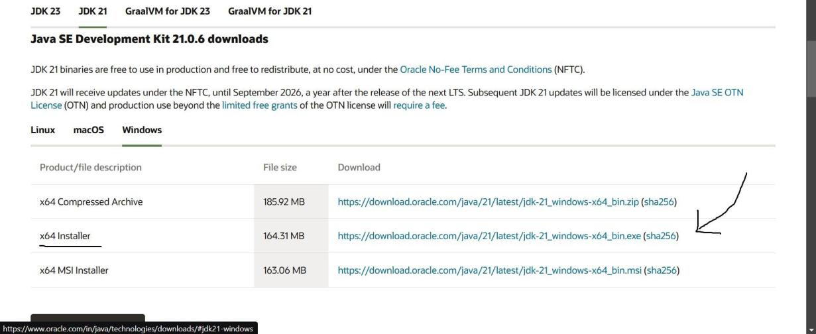

**Step-3**:Setting up environmental variables.

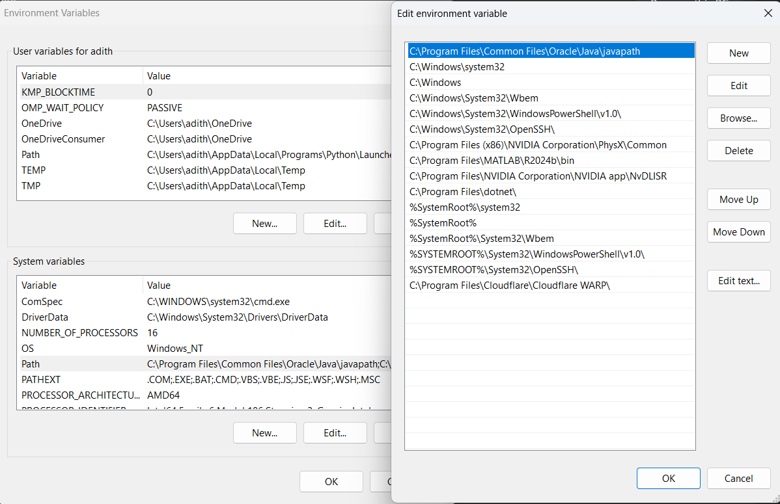

*Windows c -> C-drive -> program files ->Java -

>JDK-21->select bin

*Select and open environmental variable in search

bar-> either select system variables or user

variables-> select path-> click edit->New-> paste

the bin-> finish the setup(apply the changes).

~for verifying the installed version

Open cmd-> type java --version

~command propt

Javac filename.java ->compiling.

Java filename.java ->displaying

**PROGRAM-1(Rectified):**

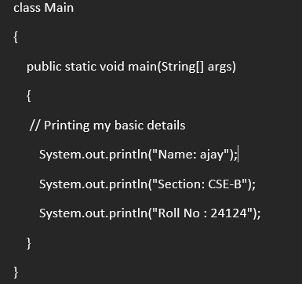

**Output:**

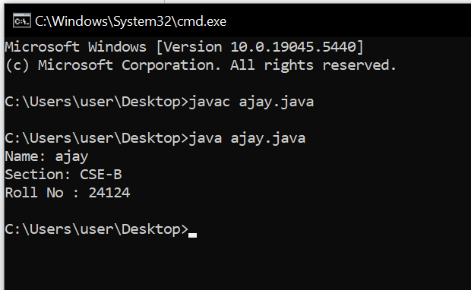

**WEEK-2:**

**PROGRAM-1:**

**Aim:**Write a java program for SI

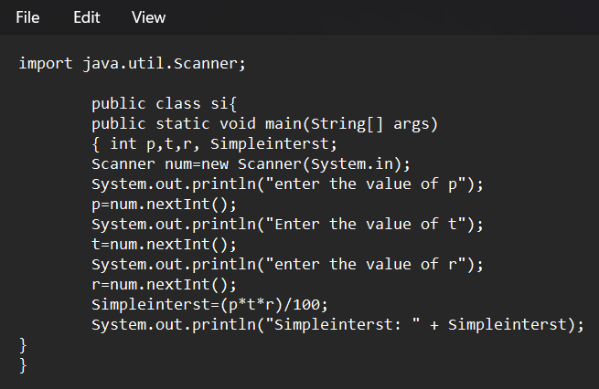

**Output:**

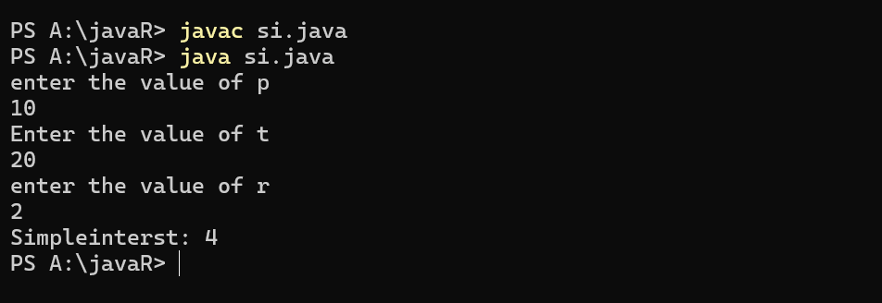

**ERROR TABLE*:***

|  |  |
| --- | --- |
| **Code Error** | **Code rectification** |
| 1.Giving space between next and Double.  2.Not giving parenthesis after closing the input. | 1.Should not give space between next and Double.  2.We must put parenthesis after closing the input. |

**PROGRAM-2:**

**Aim:**Write a program in java for area of

rectangle.

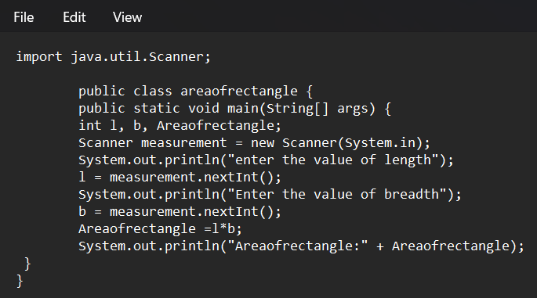

**Output:**

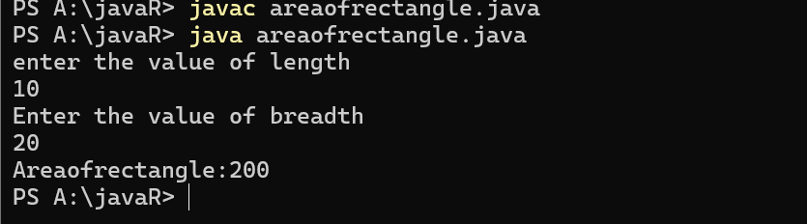

**ERROR TABLE:**

|  |  |
| --- | --- |
| **Code Error** | **Code rectification** |
| 1.While using for iteration, not giving the conditions correctly.  2.Declaring the data type as double instead of int. | 1.We should give iterative statements correctly.  2.We should give the data type as int for integers. |

**PROGRAM-3:**

**Aim:**Write a program in java for area oftriangle using heron’s formula.

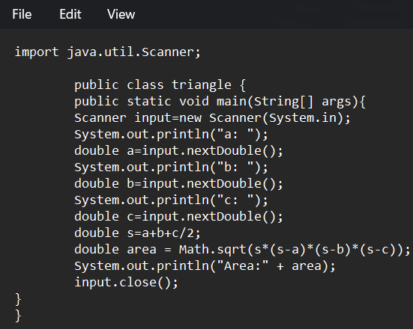

**Output:**

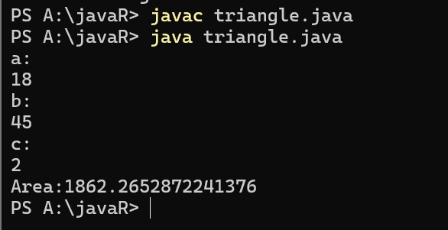

ERROR TABLE:

|  |  |
| --- | --- |
| **Code Error** | Code rectification |
| 1.While printing the variable not giving + sign.  2.Not closing the scanner. | 1.We should give correct indentation.  2.Closing the scanner is must. |

**PROGRAM-4(a):**

**Aim:**Write a program in java for converting temperature from celsius to fahrenite.

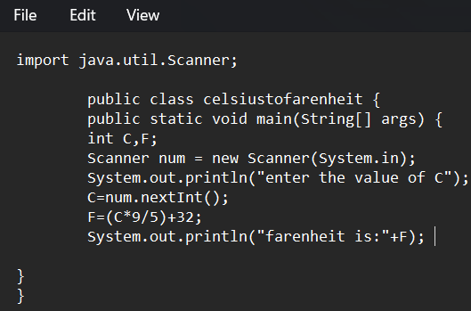

OUTPUT:

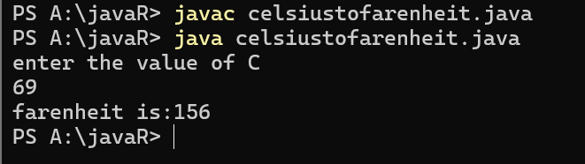

**PROGRAM-4(b):**

**Aim:**Write a program in java for converting temperature from fahrenite to celsius.

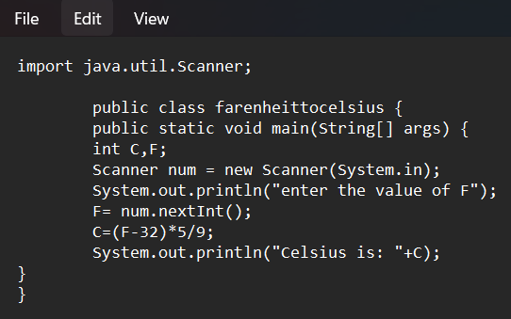

**Output:**

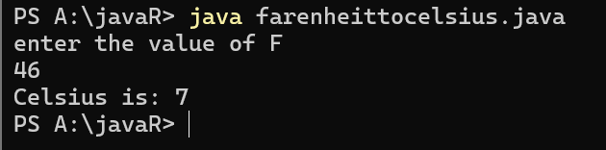

**ERROR TABLE:**

|  |  |
| --- | --- |
| **Code Error** | **Code rectification** |
| 1.While printing the variable not giving + sign.  2.Not closing the scanner. | 1.We should give correct indentation.  2.Closing the scanner is must. |

**PROGRAM-5:**

**Aim:**Write a program in java for factorial of a number.

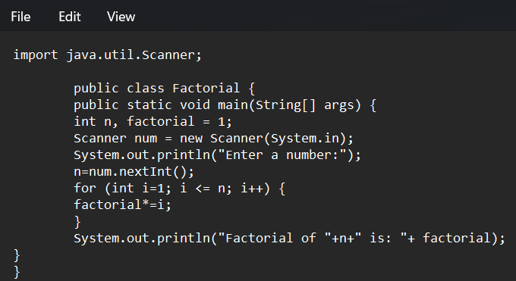

OUTPUT:

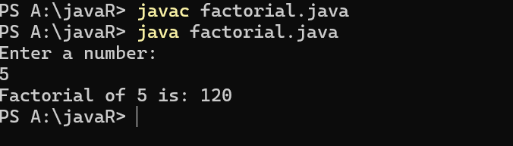

ERROR TABLE:

|  |  |
| --- | --- |
| **Code Error** | **Code rectification** |
| 1.While using for iteration, not giving the conditions correctly.  2.Declaring the data type as double instead of int. | 1.We should give iterative statements correctly.  2.We should give the data type as int for integers. |

**PROGRAM-6:**

**Aim:**Write a program in java for fibonacci series.

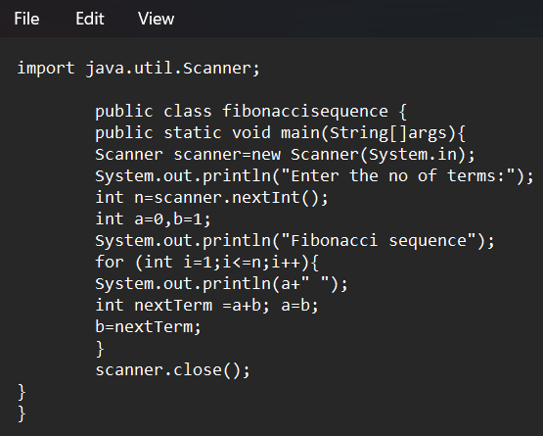

OUTPUT:

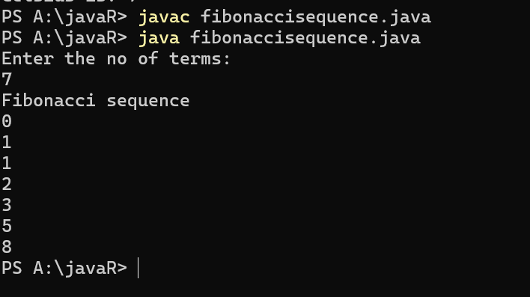

ERROR TABLE:

|  |  |
| --- | --- |
| **Code Error** | **Code rectification** |
| 1.Giving space between next and Double.  2.Not giving parenthesis after closing the input. | 1.Should not give space between next and Double.  2.We must put parenthesis after closing the input. |

**WEEK -3:**

**PROGRAM-1:**

**AIM: To create java program with following instructions :**

**1.Create a class with name Car**

**2.Create four attributes named car_color,car_brand, fuel_type, mileage**

**3.Create these methods named start(),stop(),service()**

**4.Create the objects named car, car1,car2**

**CODE:**

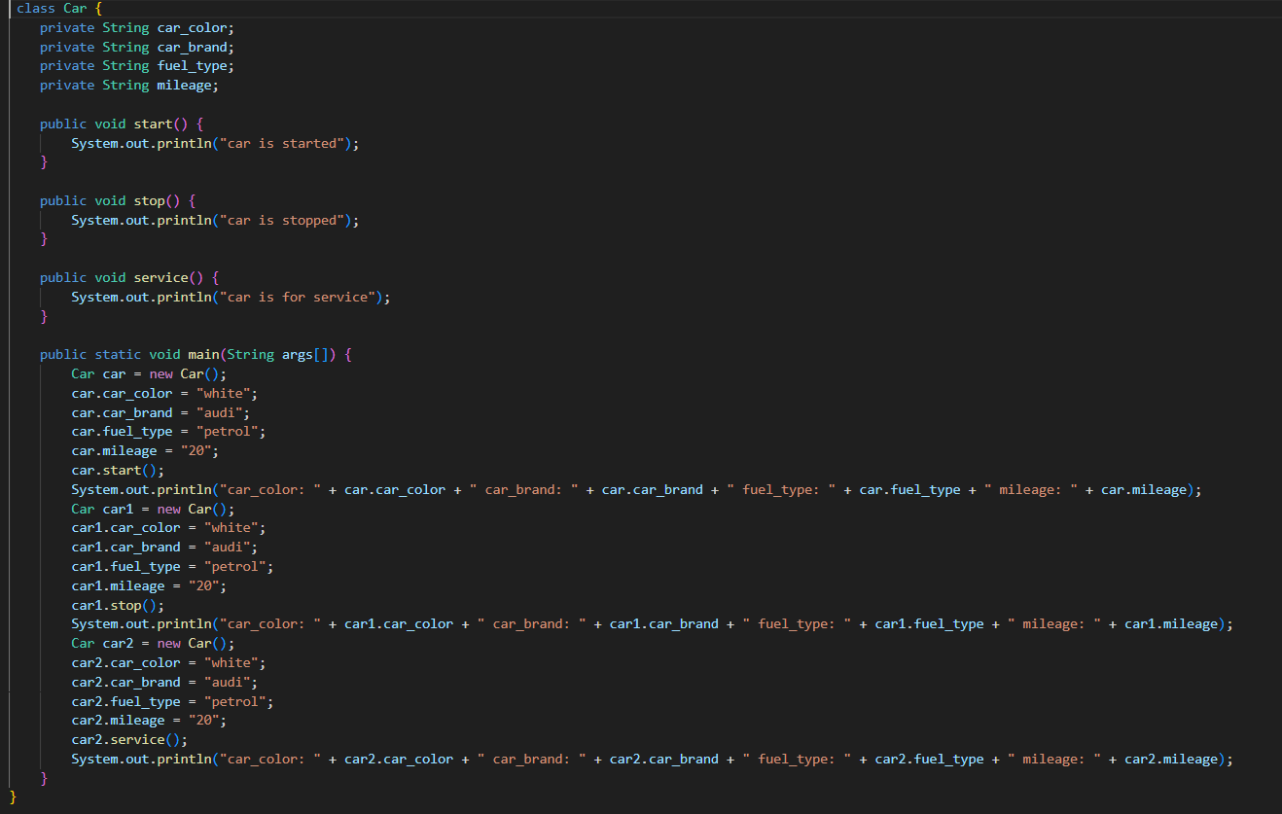

**OUTPUT:**

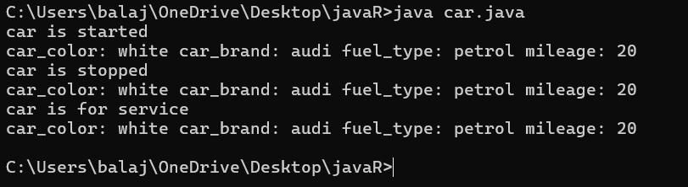

**Error table:**

|  |  |  |  |
| --- | --- | --- | --- |
| **S.no** | **Error name** | **Cause of error** | **Rectification** |
| **1** | **Syntax Error** | **Missing ‘{‘** | **‘{‘ added** |
| **2** | **Compile time Error** | **Mispelled Variable call** | **Rectified with**  **Correct variable name** |
| **3** | **Case sensitive error** | **Uppercase and lowercase** | **rectified** |

**Class diagram:**

|  |
| --- |
| **car**  **---------------------- --- -**  **-car_color:string**  **-car_brand:string -**  **-fuel_type:string**  **-milage:double**  **---------------------- ---**  **+start():void**  **+stop():void**  **+service():void** |

**PROGRAM-2:**

**Aim:To create a class BankAccount with methods deposit() and withdraw() create two subclasses savingsaccount and checkingaccount override the withdraw method in each subclass to impose different withdrawal limits and fees  
  
CODE:**

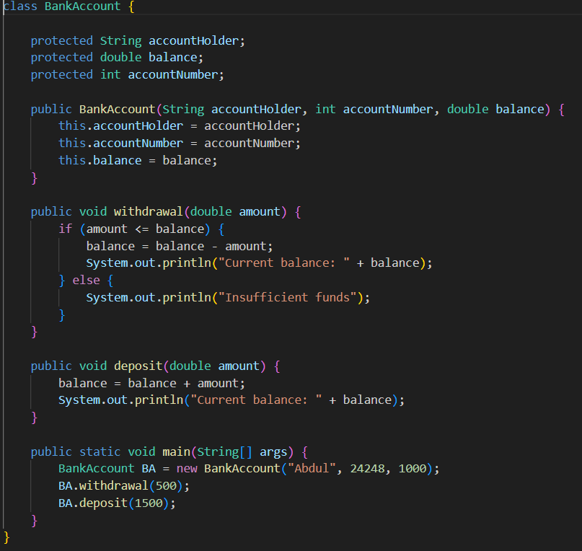

**OUTPUT:**

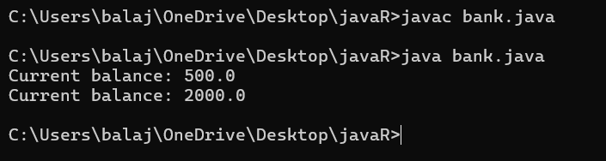

**Error table:**

|  |  |  |  |
| --- | --- | --- | --- |
| **S.no** | **Error name** | **Error name** | **Rectification** |
| **1** | **Name Error** | **Undefined name** | **Correct variable**  **Name replaced** |
| **2** | **Syntax Error** | **Missing Parenthesis** | **Parenthesis Added** |
| **3** | **Logical Error** | **Incorrect Condition** | **Condition Rectified** |

**Class diagram:**

|  |
| --- |
| **BankAccount**  **----------------------------------------------------------**  **-balance: double**  **----------------------------------------------------------**  **+BankAccount(intialBalance: double)**  **+deposit(amount: double):void**  **+withdraw(amount: double):void** |

**Week-4**

**Program 1:**

**AIM : Write a java program with class named book the class should contain various attributes such as title ,author, year of publication .It should also contain a constructor with parameters with initializes title ,author and year of publication . create a method which displays the details of the book (display the details of two book i.e, create two books and objects with details).**

**Code:**

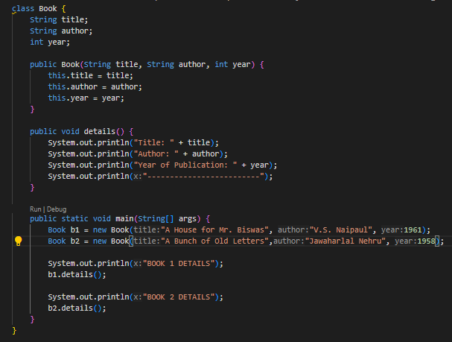

**Output:**

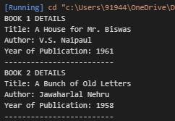

**Error :**

|  |  |  |  |
| --- | --- | --- | --- |
| **S.No** | **Error type** | **Reason for error** | **Rectification** |
| **1** | **syntax error** | **Forgot to keep }**  **At last** | **} is added** |
| **2** | **Logical error** | **Incorrect logic** | **Correct logic** |
|  |  |  |  |

**Class diagram:**

|  |
| --- |
| **Book** |
| **title : String**  **author : String**  **year : int** |
| **+ book(title: String, author: String, year: int)**  **+ details(): void** |

**Program 2:**

**AIM :**

**Write a java program to create a class named myclass with a static variable count of int type and initialize to zero and a constant variable pie of double data type ,initialize to 3.1415 as attributes of that class now define a constructor for my class that increments the count variables each time an object of my class is created variable each time an object of myclass is created. Finally print the final values of count and pie variables.**

**Code:**

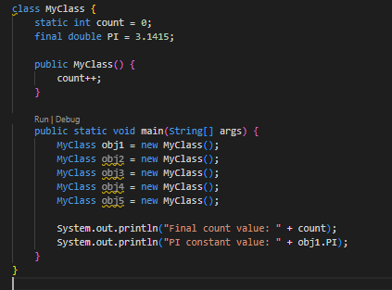

**Output:**

**C:\Users\91944\OneDrive\Pictures\Screenshots\Screenshot 2025-03-12 013521.png**

Error:

|  |  |  |  |
| --- | --- | --- | --- |
| S.No | Error type | Reason for error | Rectification |
| 1 | syntax error | String forgot in main function | String is added |
| 2 | Logical error | Incorrect logic | Correct logic |

**Class diagram:**

|  |
| --- |
| Myclass |
| Count : int  PIE : double |
| +Myclass() |